

**It’s time to get Creative!**

**(light snacks provided)**

**Join this fun class to build your supply of greeting cards and be ready for any occasion! You choose the sentiment.**

**New cards offered each month**

**6 for $15**

**Class Offered:**

**Wednesday 9/17/14 9am-11am**

**Or**

**Friday 9/19/14 7pm-9pm**

**It’s a GRAB BAG!!**

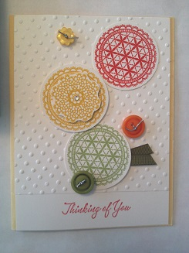 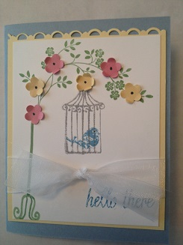 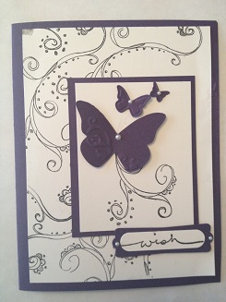

**Make 2 cards of each design**

**Class must be paid at time of registration (Deadline) 9/15/14: cash or checks payable to: Jodi Thompson**

**Contact me at:** [**Jodi_l_thompson@comcast.net**](mailto:Jodi_l_thompson@comcast.net) **or 720-789-6021 to Register**