

**It’s time to get Creative!**

**(light snack provided)**

Join this fun class to build your supply of greeting cards and be ready for any occasion! You choose the sentiment.

New cards offered each month

**6 for $15**

**Wednesday 10/15/14 9am-11am**

**Or**

**Friday 10/17/14 7pm-9pm**

**Step In To Fall!**

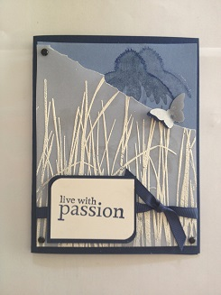 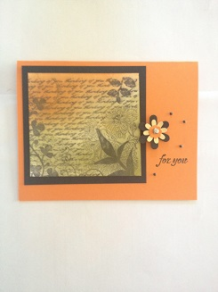 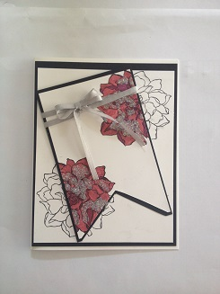

**Make 2 cards of each design**

**Class must be paid at time of registration (Deadline) 10/13/14: cash or checks payable to: Jodi Thompson**

**Contact me at:** [**Jodi_l_thompson@comcast.net**](mailto:Jodi_l_thompson@comcast.net) **or 720-789-6021 to Register**